Photo | Species | Common Name | Description | Price per Potted Plant
 |  |  |  | 4” | 6.5” | 2 gal
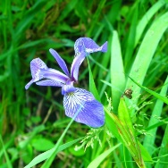 | Iris versicolor | Blue Flag Iris | Large blue showy flowers bloom from May to July in moist to wet, organically rich soil. Drought tolerant. Gets 2 to 3ft tall in full sun to light shade. |  | $10
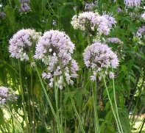 | Allium cernuum | Nodding Onion | Nodding white to pale lilac flowers bloom early to mid-summer. Prefers average to dry soil and sun to part-sun. About 3ft tall. |  | $10
 | Monarda fistulosa | Wild Bergamot | Mass of scented, violet fuzzy flowers bloom mid to late summer. Easy to grow, average to dry soil. Gets ~4ft tall. Prefers full sun. |  | $10
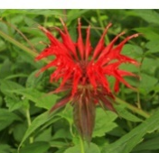 | Monarda didyma | Bee Balm | Fireworks from mid-summer to fall atop 3ft stems. Moist soils in full to part sun. Attracts hummingbirds and native bees. |  |  | $12
 | Asclepias tuberosa | Butterfly-weed | Bright orange flowers June through August. Drought tolerant, deer resistant, and larval host for monarch and frosted elfin butterflies. 2ft tall. Prefers full sun. | $8
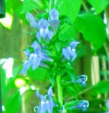 | Lobelia siphilitica | Great Blue Lobelia | Blooms bright blue in late summer. Attracts birds, hummingbirds. 1 to 3ft tall; full sun to light shade. |  | $10
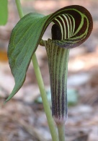 | Arisaema triphyllum | Jack-in-the-Pulpit | Unusual hooded flowers in late spring. Dry to moist soil in dappled shade. Fall berries are food for wildlife. Poisonous to humans and pets. | $8
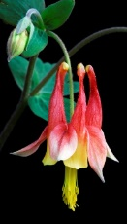 | Aquiliegia canadensis | Wild Columbine | Aquila means eagle for the talon-shaped flowers. Attracts hummingbirds. Larval host for the Columbine Duskywing butterfly. Rounded foliage has burgundy tones. | $10
 | Heliopsis helianthoides | Oxeye Sunflower | Reliable yellow rays in mid-summer, average to moist soil, drought tolerant. Easy to grow. Good in clay soils. Loosely bunched stems get 3 to 4ft tall. So pretty, you won’t mind staking it. Sun to part-sun. | $8 |  | $14
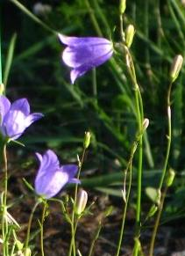 | Campanula rotundifolia | Harebell | Delicate looking blue-violet bells are continually in bloom from May through late October, even after a heavy rainfall. Gets ~8” tall, 6” wide. Likes dry sandy soil and wet clay, sun to shade. Drought tolerant, and grows well in containers. Concern Status in NY. |  | $12
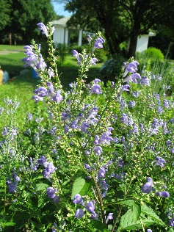 | Scutellaria incana | Hoary Skullcap | Blue “snapdragon” type flowers bloom in spikes of color mid to late summer at the top of 3ft to 4ft stems. Prefers sun to part-sun, and average to dry soil. Drought tolerant. |  | $10
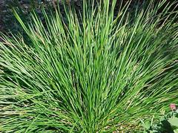 | Deschampsia cespitosa | Tufted Hairgrass | Nearly evergreen clumping ornamental grass, 1-3ft tall, sun to shade in average soil. Prefers moist soil. |  | $10
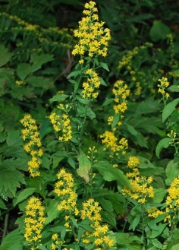 | Solidago flexicaulis | Zig-Zag Goldenrod | Low-growing perennial ground cover forming dense colonies with columns of fall-blooming yellow flowers. Performs well in a wide array of soil and moisture types in shade to part shade. |  | $10

